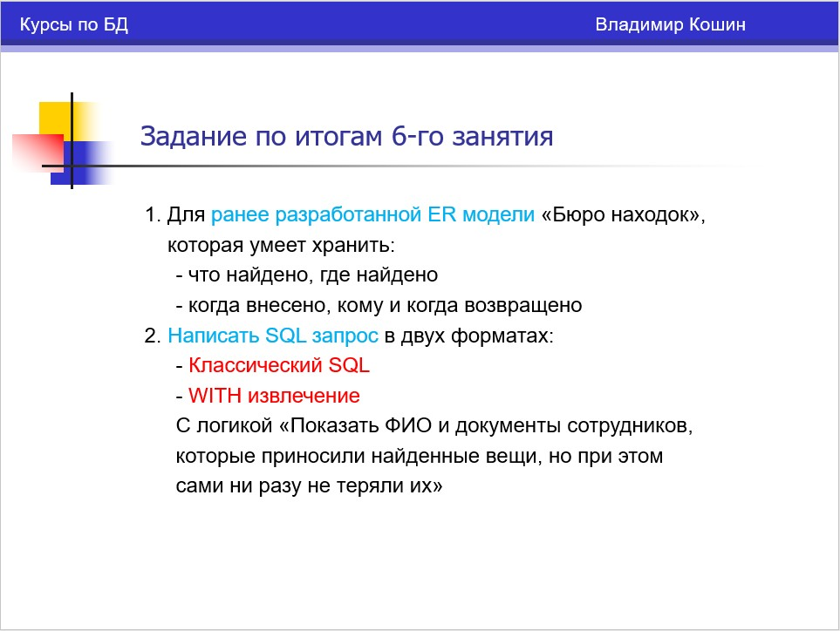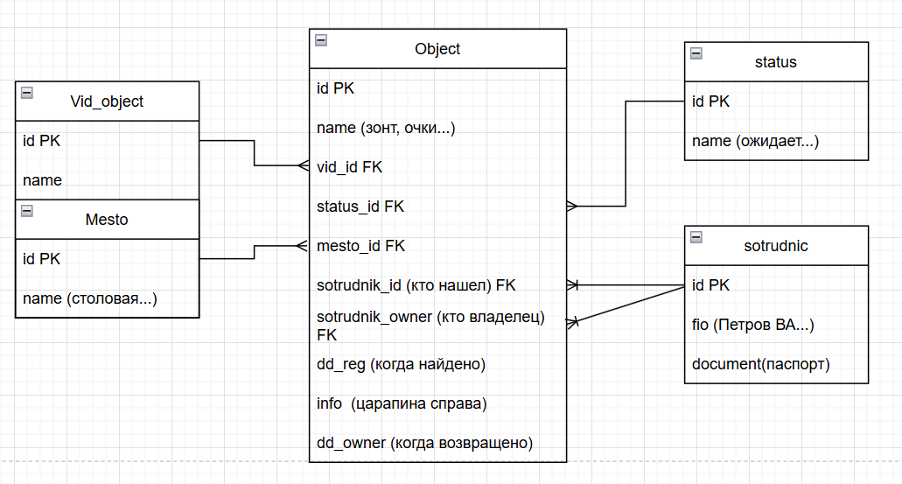
create table vid(
id bigserial not null,
name varchar(50),
primary key(id)
)
insert into vid (name) values ('очки'),('зонт'),('ключи')

create table status(
id bigserial not null,
name varchar(50),
primary key(id)
)
insert into status (name) values ('ожидает'),('вручено'),('утилизировано')

create table mesto(
id bigserial not null,
name varchar(50),
primary key(id)
)
insert into mesto (name) values ('не указано'),('проходная'),('столовая'),('зал')

create table sotrudnik(
id bigserial not null,
fio varchar(255),
document varchar(255),
primary key(id)
)
insert into sotrudnik (fio, document) values ('аноним','');
insert into sotrudnik (fio, document) values ('Иванов Иван','');
insert into sotrudnik (fio, document) values ('Петрова Евгения','');
insert into sotrudnik (fio, document) values ('Потапов Семен','');
insert into sotrudnik (fio, document) values ('Сидорчук Екатерина','');
insert into sotrudnik (fio, document) values ('Мария Ивановна','курьер');
insert into sotrudnik (fio, document) values ('Семен Семеныч','стажер');

create table predmet(
id bigserial not null,
name varchar(100),
vid_id bigint not null,
status_id bigint,
mesto_id bigint,
sotrudnik_id bigint,
owner_id bigint,
info varchar(100),
dd_reg timestamp(0),
dd_owner timestamp(0),
primary key(id),
foreign key(vid_id) references vid(id),
foreign key(status_id) references status(id),
foreign key(mesto_id) references mesto(id),
foreign key(sotrudnik_id) references sotrudnik(id),
foreign key(owner_id) references sotrudnik(id)
)
insert into predmet(name,info,dd_reg,vid_id,status_id,mesto_id,sotrudnik_id)
values('очки в светлой оправе','без царапин',now(),1,1,2,1)

insert into predmet(name,info,dd_reg,vid_id,status_id,mesto_id,sotrudnik_id)
values('ключи','с брелком',now(),3,1,2,1)

insert into predmet(name,info,dd_reg,vid_id,status_id,mesto_id,sotrudnik_id)
values('зонт мужской','',now(),2,1,3,4)

insert into predmet(name,info,dd_reg,vid_id,status_id,mesto_id,sotrudnik_id)
values('зонт женский','оранжевый',now(),2,1,1,4)

insert into predmet(name,info,dd_reg,vid_id,status_id,mesto_id,sotrudnik_id)
values('очки толстой оправе','темные',now(),1,1,2,2)

update predmet
set
owner_id = 6,
dd_owner = now()
WHERE (id = 4)

update predmet
set
owner_id = 7,
dd_owner = now()
WHERE (id = 2)

update predmet
set
owner_id = 6,
dd_owner = now()
WHERE (id = 5)
----------------Классический sql и WITH извлечение
select s.fio,
s.document
from sotrudnik s
where s.id in (
select sotrudnik_id
from predmet
where owner_id is Null)

with sotrudnik_found_notlose as
(select sotrudnik_id
from predmet
where owner_id is Null)
select s.fio,
s.document
from sotrudnik s
where s.id in (
select sotrudnik_id from sotrudnik_found_notlose)

)

